Bo Cui July 14, 2011
Weekly report
- In programming, I find some information about the CNN model function.
- The model function is a gradient descent process. In static environment, after a few loops, the CNN activity will reach a steady state. It means that the activity will not change, nor transmit. So the robet must reach the target before the CNN activity reaches a steady state. （CNN paper）
- In big maps, we should adjust the coefficients to extend the convergence time. Last week, I cannot use a map bigger than 15*15. That is the problem.
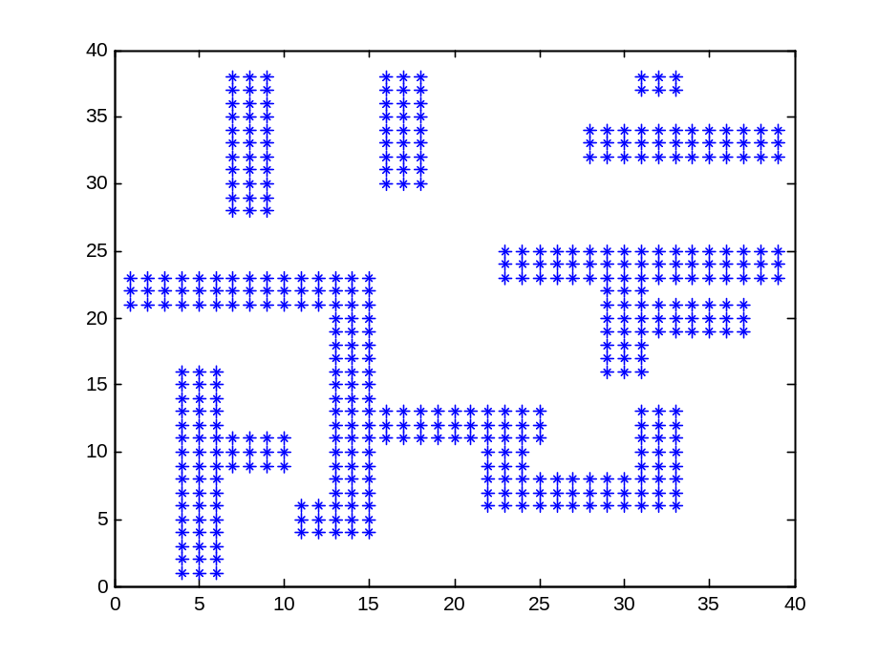
Fig. 1
- Test the coefficients in Fig 1
⑴ RX:
a) RX=10, h=0.1 It reaches the steady state at [25, 5];
b) RX=100, h=0.1 It reaches the steady state at [27, 5];
c) RX=10000, h=0.1 It reaches the steady state at [31, 5];
d) RX=100000000, h=0.1 It reaches the steady state at [32, 5];
⑵ h:
a) RX=10, h=0.2 It will be wrong (negative value);
b) RX=10, h=0.15 It will be wrong (negative value);
c)RX=10, h=0.14 It reaches the steady state at [28, 5];
⑶ both
RX=10000, h=0.13 It reaches the steady state at [33, 5];
RX=100000000, h=0.14 It reaches the steady state at [37, 7] (finally be wrong);
Conclusion: the maps will be valuable when the path (from start point to target point) is within 60 steps.
- several maps using CNN model
- map 1: 2-U map
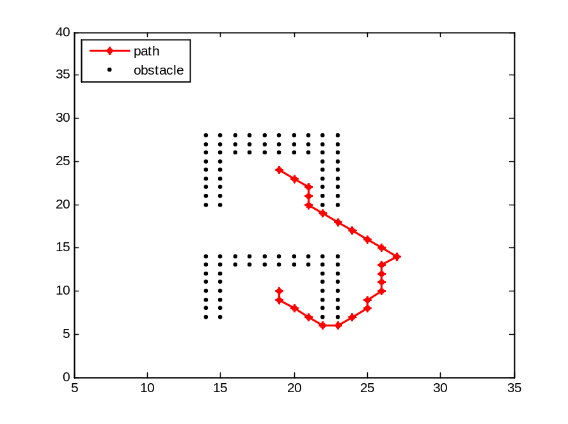
Map 1
- map 2: (to tell you in this map, how far it can transmit)
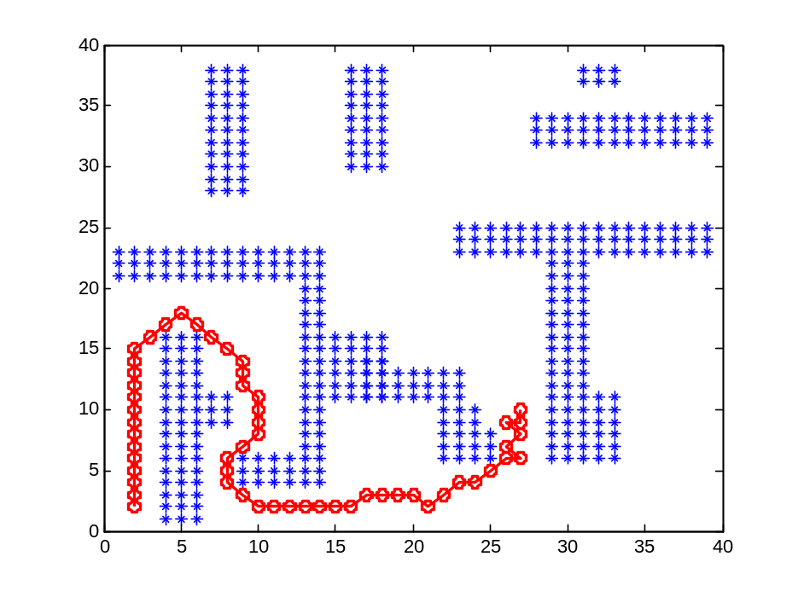
Map 2
- map 3:
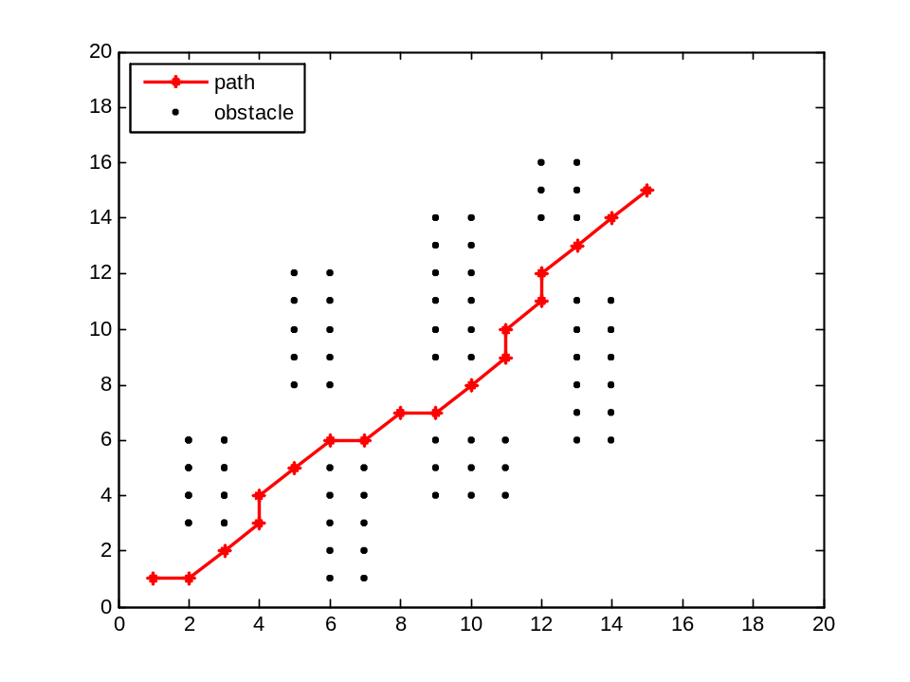
Map 3
- Map 4 using virtual obstacle algorithm
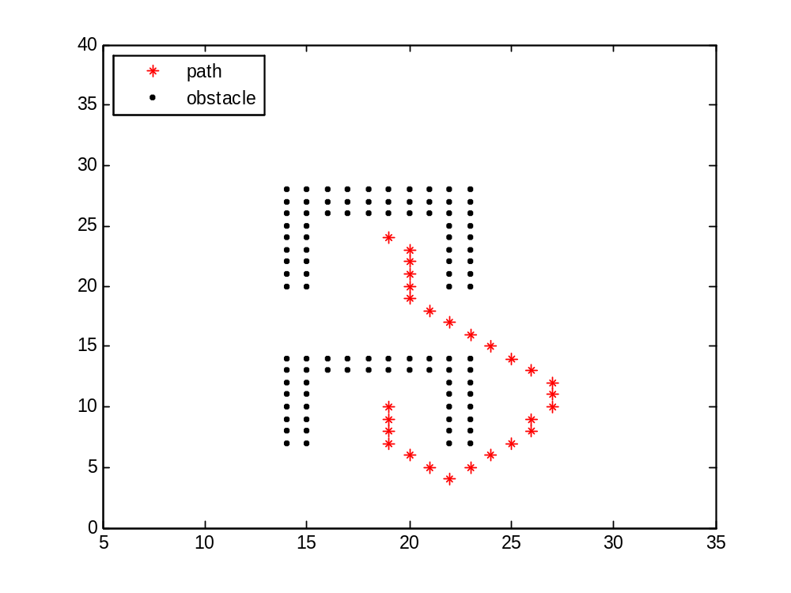
Map 4

